Gedling Borough Council
Community Infrastructure Levy (CIL)

Infrastructure Funding Statement 2021/22

Published December 2022

1 INTRODUCTION
Welcome to the Gedling Borough Council Infrastructure Funding Statement. This statement sets out the income and expenditure relating to the Community Infrastructure Levy (CIL) and Section 106 (s106) Agreements during the financial year 21/22.
As a result of the changes made by the Community Infrastructure Levy (Amendment) (England) (No. 2) Regulations 2019, Local Authorities are required to produce Infrastructure Funding Statements on an annual basis.
Income collected from the CIL and / or s106 (collectively known as ‘planning obligations’ or ‘developer contributions’) is used to help fund the provision of infrastructure which is necessary to support and enable development and growth within the Borough.
Sections 2 and 3 of this statement will provide details of the progress in relation to the collection and expenditure of income generated through the CIL and s106 respectively for the last financial year.
Section 4 sets out the planned future expenditure of income generated through these mechanisms over the next reporting period.
1.1 Community Infrastructure Levy & Section 106 Agreements
The Community Infrastructure Levy is a tariff-based charge on the development of new floorspace within the borough. Monies collected through the CIL can be used to fund a wide range of infrastructure (e.g. roads, medical practices and the provision of open space) that is required to meet the future growth needs of the borough.
The Gedling Borough Community Infrastructure Levy (CIL) Charging Schedule was approved by Full Council on 15th July 2015 and came into effect on 16th October 2015. Planning applications decided on or after 16th October 2015 may therefore be subject to CIL.

Section 106 agreements are private agreements, made between local authorities and developers, which can be attached to a planning permission to ensure that a certain development that may otherwise be unacceptable in planning terms, meets the local planning authorities policy requirements. Typical forms of Section 106 Obligations include:
- Site-specific financial contribution;
- Non-financial obligations; and
- Provision of on-site affordable housing.
1.2 Summary of Headlines within Statement
Table 1. Key Headlines from the Statement.
Summary of CIL Receipts
A total of £3,214,932 in CIL receipts were collected during the financial year 2021/22.

A total of £4,272,039 receipts were retained at the end of the financial year 2021/22. Of this, £4,097,740 is to be used towards the provision of Strategic Infrastructure within the Borough, whilst £174,300 remains for Infrastructure projects identified through the Neighbourhood portion of the CIL.

A total of £373,379 was passed to Local Parishes during 2021/22 in accordance with Regulations 59A.

A total of £160,747 was allocated to cover the administrative costs of implementing and monitoring the CIL during 2021/22.

Summary of Section 106 Contributions
During the 2021/22 financial year £781,671 was collected in capital contributions through Section 106 Obligations. £75,533 was collection in revenue contributions during the same period.

A total of £13,825 capital and £29,729 revenue contributions have been spent on infrastructure within Gedling Borough Council during the 2021/22 financial year.

At the end of the financial year 2021/22, £3,176,204 worth of capital contributions were retained by Gedling Borough Council.

Provision for Affordable Housing was secured by way of Section 106 Obligations on four different developments, including a major development consisting of entirely affordable units.

2 COMMUNITY INFRASTRUCTURE LEVY
The amount of CIL payable depends on where the development is located within the borough, the type of use the development comprises of, and the net additional increase in floorspace (£ per Sqm).
Gedling Borough Council’s Charging Schedule currently identifies two different types of Uses which are liable for the CIL. Retail development chargeable by a flat rate across the borough whilst new residential development is split into three different zones. The Charging Schedule and Map of the different zones are available to view from our website at https://www.gedling.gov.uk/cil/.
Alongside the Charging Schedule Gedling Borough Council also adopted a Regulation 123 List in accordance with the regulations in force at the time. Expenditure of the Strategic CIL receipt was approved for the following infrastructure projects:
- The Gedling Access Road (GAR);
- Secondary School Contributions for Gedling Colliery / Chase Farm and Top Wighay Farm strategic sites; and
- The Gedling Country Park Visitors Centre.
The Regulation 123 List was abolished as part of the CIL Amendment Regulations 2019, and replaced with the ‘Infrastructure List’. No new projects have been added to the Infrastructure List.
Unlike Section 106 Agreements, the CIL payable is a fixed rate which is mandatory and non-negotiable. The charge becomes payable upon the commencement of development.
2.1 CIL Income
Table 2 below provides an annual cumulative total of all CIL receipts since Gedling Borough Council first adopted the CIL in 2015. A breakdown of these receipts is provided in greater detail further into the report.
Table 2. Cumulative Total CIL Receipts Retained (to the nearest £)
Year | Income
2015/16 | £0
2016/17 | £36,171
2017/18 | £420,148
2018/19 | £1,038,139
2019/20 | £1,276,677
2020/21 | £1,671,993
2021/22 | £4,272,039

Gedling Borough Council adopted the CIL on 16th October 2015. In accordance with the Community Infrastructure Levy (Amendment) (England) (No. 2) Regulations 2019, any planning application which was determined prior to this date is not chargeable. It is for this reason, along with a gap between the granting of permission and implemented, that no receipts were collected during the 2015/16 financial year.
2.2 Breakdown of CIL for 2021/22
During the reported year 2021/22, 18 Demand Notices were issued totalling £4,794,417 in CIL Receipts. To date £3,528,708 of these receipts have been collected. The remaining sums will be collecting in accordance with the relevant payment plans as approved in the Councils Charging Schedule. The collection of the remaining sums from these Demand Notices will be reported in future Infrastructure Funding Statements in accordance with relevant payment policies.
During the reported year 2021/22 there has been a total of £3,214,932 collected in CIL receipts from across 24 different developments. A summary of the receipts collected during the year is detailed in Table 3 below.
Table 3. Annual Breakdown of CIL Receipts 1st April 2021 - 31st March 2022 (to the nearest £)
Total Receipts Collected | £3,214,932
Neighbourhood Portion of CIL Receipts | £623,342
Strategic Element of CIL Receipts | £2,430,843
Administration Element of CIL Receipts | £160,747
Receipts Passed to Local Parishes | £373,379
Receipts Awarded to Non-Parish Neighbourhood Projects | £80,760
CIL Receipts Retained at End of Year | £4,272,039

Of the receipts which were collected during 2021/22, £2,430,843 is to be spent on strategic infrastructure projects that were identified on the Infrastructure List (previously Regulation 123 List), while £623,342 is to be spent in the locality it was collected as part of the neighbourhood portion of the CIL.
In accordance with Regulation 59A of the Community Infrastructure Levy (Amendment) (England) (No. 2) Regulations 2019, a total of £373,379 worth of CIL Receipts have been passed directly to the Local Parishes from where they were collected.
£160,747 (5%) of all receipts collected during the financial year, have been set aside to cover the administration costs as permitted by the Community Infrastructure Levy (Amendment) (England) (No. 2) Regulations 2019.
During the financial year 2021/22, projects which were identified as suitable for funding through the Neighbourhood portion of the CIL, in accordance with Regulation 59F of the Community Infrastructure Levy (Amendment) (England) (No. 2) Regulations 2019, were awarded a total of £80,760.
A total of £4,272,039 in CIL receipts were retained at the end of the financial year 2021/22.
2.2.1 Strategic CIL
Since its adoption of CIL, to the end of the financial year 2021/22, Gedling Borough Council has collected £4,097,740 towards the provision of its strategic projects.
Table 4. Annual Strategic CIL Collected (to the nearest £)
Year | Income
2015/16 | £0
2016/17 | £33,695
2017/18 | £333,580
2018/19 | £530,147
2019/20 | £332,116
2020/21 | £437,359
2021/22 | £2,430,843
Total | £4,097,740

Following its introduction in 2015, the strategic portion of the CIL collected has been retained for the construction of Gedling Access Road (GAR) which remains the Council’s first priority in terms of key infrastructure within the Borough. The Borough Council has agreed to make a contribution of up to £4.48 million from the Strategic CIL receipts.
The GAR is a new 3.8km single carriageway road which provides a link between the B684 Mapperley Plains and the A612 Trent Valley Road / Nottingham Road. This new piece of infrastructure is vital to supporting the residential growth in this area. Construction of the GAR began in January 2020 and was completed in Spring 2022.

Figure 1. Map of Gedling Access Road
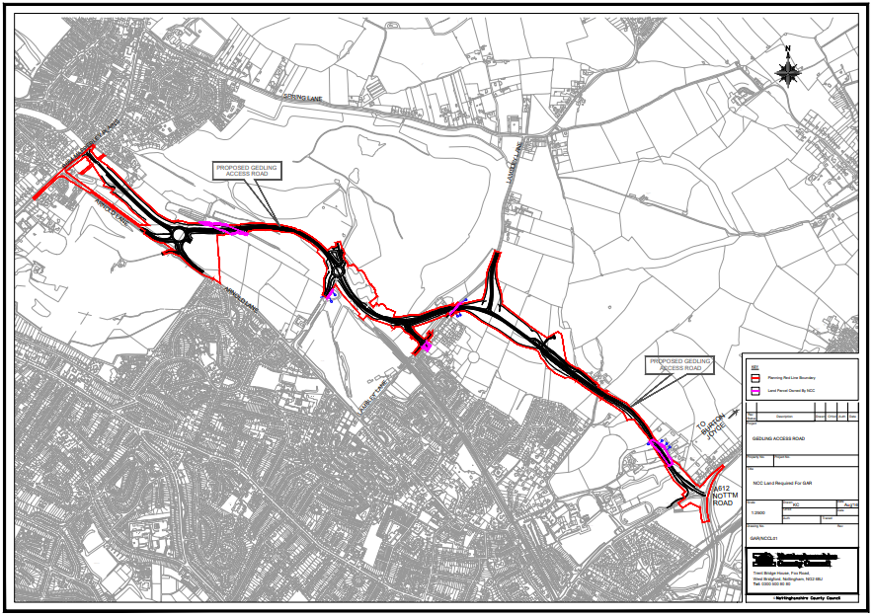
2.2.2 Neighbourhood CIL
Under the Community Infrastructure Levy (Amendment) (England) (No. 2) Regulations 2019 a ‘meaningful proportion of CIL receipts are to be passed to local town or parish councils for the area where development takes place. This is known as the ‘neighbourhood portion’. The neighbourhood portion to be passed to the local council is set at 15% of the relevant CIL receipts (up to a cap of £100 per existing council tax dwelling) or 25% with no maximum cap specified where there is a Neighbourhood Development Plan in place. At this time there are four Neighbourhood Plans ‘made’ within Gedling Borough:
- Burton Joyce Neighbourhood Plan,
- Calverton Neighbourhood Plan,
- Linby Neighbourhood Plan, and
- Papplewick Neighbourhood Plan.
Table 5 below shows the portion of the Neighbourhood CIL Receipts which have been collected on behalf of local Parish Councils.
Table 5. Neighbourhood CIL Awarded to Local Parishes (to the nearest £)
Year | Income
2015/16 | £0
2016/17 | £3,842
2017/18 | £12,374
2018/19 | £8,059
2019/20 | £23,808
2020/21 | £45,304
2021/22 | £373,379
Total | £466,766

Where there is no Parish Council, Regulation 59A of the Community Infrastructure Levy (Amendment) (England) (No. 2) Regulations 2019 places a duty on charging authorities to allocate at least 15% (up to a cap of £100 per existing council tax dwelling) or 25% (uncapped) where there is a ‘made’ Neighbourhood Plan, of CIL receipts to spend on priorities that should be agreed with the local community in areas where development is taking place. Gedling Borough Council undertake annual consultations with local residents and groups to identify and assess projects which may be suitable for Non-Parish neighbourhood funding. Where no suitable projects are identified the Neighbourhood portion is carried over to the next financial year. Further information regarding the Neighbourhood portion of the CIL can be found on the Gedling Borough Council website at https://www.gedling.gov.uk/cil/.

Gedling Borough has 11 Parishes where the Neighbourhood portion of CIL Receipts will be passed to the Parish Councils if developments take place in those areas. The Parishes cover the following areas:

- Bestwood Village;
- Burton Joyce;
- Calverton;
- Colwick;
- Lambley;
- Linby;
- Newstead;
- Papplewick;
- Ravenshead;
- St Albans, and
- Woodborough.

In accordance with the Community Infrastructure Levy (Amendment) (England) (No. 2) Regulations 2019, Parish Councils must publish their own annual reports which detail funding and expenditure for each year where they have received monies passed down through the Neighbourhood Portion through CIL.
It should be noted that the extent of the Parishes does not cover the majority of the urban area of Gedling Borough (with the exception of Colwick). This creates a gap in the coverage for the Neighbourhood portion in the Borough. When development takes place in this area Gedling Borough Council will determine, in consultation with its residents, how to expend this element of the CIL in accordance with Regulation 59F of with the Community Infrastructure Levy (Amendment) (England) (No. 2) Regulations 2019.
Below is a table showing the amount of CIL which has been collected and allocated towards the Non-Parish Neighbourhood element during the last financial year.
Table 6. Non-Parish Neighbourhood CIL Collected (to the nearest £)
Year | Income
2015/16 | £0
2016/17 | £2,476
2017/18 | £50,397
2018/19 | £91,344
2019/20 | £46,423
2020/21 | £50,957
2021/22 | £249,963
Total | £491,560

To date Gedling Borough Council have awarded a total of £317,260 through the Non-Parish Neighborhood portion, to seven different infrastructure projects. Table 7 below provides a summary of these projects. The projects can be found in greater detail in the relevant annual Infrastructure Funding Statements which are available on the Gedling Borough Council website.

Table 7. Summary of Non-Parish Neighbourhood CIL Awards
Project | Award | Year of Submission
Cinderpath Lighting | £3,500 | 17/18
Car Park Extension at Gedling Country Park | £100,000 | 18/19
Changing Room Facilities at Lambley Lane | £40,000 | 18/19
Green Lung Corridor | £50,000 | 19/20
Arnold Marketplace Development | £43,000 | 19/20
Footpath Extension at Willow Park | £25,000 | 20/21
Internal works and alterations at Netherfield Forum Children, Young People and Families Hub | £55,760 | 20/21
At the end of the financial year 2021/22 a total of £174,300 in CIL Receipts were retained by Gedling Borough Council for allocation towards the funding of future nominated projects. Below is a brief description of the latest projects which were granted awards through the Non-Parish Neighbourhood portion of the CIL:

Footpath Extension at Willow Park
In 2022 £25,000 was awarded to the creation of a new surfaced path extension linking Willow Lane via Willow Park with Jessop’s Lane to create an accessible and usable ‘green walking route’ for local residents to enjoy.
The new footpath extension will allow safe access into and out of the existing green space for all users. It will be DDA compliant, 1.2m wide to allow accommodation for wheelchair users and pushchairs, and be constructed of a non-slip surface.
Works were completed in August 2022. Following construction of the extension to the footpath the project will be maintained and managed by Gedling Borough Council’s Parks and Street Care Team.

Internal works and alterations at Netherfield Forum Children, Young People and Families Hub
In 2022 a total of £55,760 was awarded towards the redevelopment of the Netherfield Forum Children, Young People and Families Hub which has recently relocated to 2A Forester Street, Netherfield, formerly Trentside Medical Centre.
The award of CIL in this instance will enable the internal renovation of the building to ensure a safe usable space suitable for the needs of the charity and local residents.
Construction works are currently underway and being inspected by Gedling Borough Councils Building Control Team. Work is expected to be complete by the end of 2022.
2.2.3 CIL Administration Portion
The remaining 5% of monies collected through CIL Receipts is made available for Charging Authorities to cover the administrative costs associated with implementing and enforcing the CIL.
To date a total of £266,109 has been collected towards covering the costs of operating the CIL within Gedling Borough Council. Table 8 below shows a breakdown of the annual receipts collected towards this portion of the CIL.
Table 8. Administration CIL Collected (to the nearest £)
Year | Income
2015/16 | £0
2016/17 | £2,106
2017/18 | £20,861
2018/19 | £33,134
2019/20 | £21,176
2020/21 | £28,085
2021/22 | £160,747
Total | £266,109

3 SECTION 106 OBLIGATIONS
Gedling Borough Councils approach to planning obligations is set out within the Aligned Core Strategy 2014 (Part 1 Local Plan), the Local Planning Document 2018 (Part 2 Local Plan) and Gedling Borough Councils Planning Obligations Protocol 2014. Priorities which should be considered when negotiating planning applications include factors such as Affordable Housing, Open Space, Education and Primary Healthcare.
More detailed guidance regarding how obligations are calculated can be found in Gedling Borough Councils Supplementary Planning Documents and Guidance on the Gedling Borough Councils website at https://www.gedling.gov.uk/resident/planningandbuildingcontrol/planningpolicy/adoptedlocalplanandpolicydocuments/.
3.1 New Section 106 Agreements Signed
During the financial year 2021/22 there have been a total of 11 new planning permissions granted for larger developments which were subject to Section 106 Agreements. Table 9 below provides a list of these developments.
Table 9. List of New Section 106 Agreements 2021/22 (to the nearest £)
App Ref | Location | Breakdown of Obligations
2018/0360 | Land South Of  Main Street  Calverton  Nottinghamshire | Local Employment and Skills Plan.  20% Affordable Housing (70% Affordable Rent and 30% Shared Ownership).  Open Space Scheme (Off-site £184,558 Capital and £77,113 Maintenance Contribution).  Primary Healthcare £42,606 Contribution.  Monitoring Fee £2,205.
2020/0545, 2020/1255 and 2020/0667 (Deed of Variation) | Land at Chase Farm (former Gedling Colliery), Adjacent to Arnold Lane and Lambley Lane, Gedling, Nottingham | No new obligations. Purpose of DoV is to tie new permissions to original agreement.
2020/0258 | Land North of Papplewick Lane, Linby, Nottinghamshire | Affordable Housing Contribution £164,092.  Open Space Scheme.  Monitoring Fee £945.
2018/0817 | Car Park  North Green  Calverton  Nottinghamshire | Local Employment and Skills Plan.  Affordable Housing provision of 4 dwellings or Off-Site Contribution of £10,617.  Open Space Contribution of £10,617.  Monitoring Fee £630.
2020/1108 | Land East of 16 Kighill Lane, Ravenshead, Nottinghamshire | Open Space Capital Contribution of £26,486.46 and Maintenance Contribution of £11,138.40.  Monitoring Fee £315.
2020/1281 (Deed of Variation) | Land at Teal Close, Burton Joyce | No new obligations. Purpose of DoV to vary mortgagee clauses for 18 units of Affordable Housing.
2020/0238 | Land at Ashdale, Nottingham Road, Burton Joyce, Nottinghamshire | Local Employment and Skills Plan.  Open Space Capital Contribution of £38,710 and Maintenance Contribution of £16,279.
2020/0954 | The Phoenix  Shelford Road  Gedling  Nottinghamshire  NG4 4HU | Local Employment and Skills Plan.  Subject to re-assessment of Viability for Affordable Housing, Education and Primary Healthcare.  Monitoring Fee £630.
2020/1054 | Land At Rolleston Drive  Arnold  Nottinghamshire | Local Employment and Skills Plan.  100% Affordable Housing provision – 85 Affordable Rent and 46 Shared Ownership.  Open Spaces Scheme and Open Space Off-Site Contribution of £194,111.  Bus Stop Enhancement Contribution £25,000.  Primary Healthcare Contribution £70,986.  Monitoring Fee £1,260.
2020/0050 | Top Wighay Farm, Wighay Road, Linby, Nottinghamshire | Local Employment and Skills Plan.  17.64% Affordable Housing provision within each phase of the development – tenure split 70% Affordable Rent and 30% Shared Ownership.  Open Spaces Scheme in relation to each phase of development.  Primary School Contribution £4,750,000 and School Land Transfer.  Bus Stop Enhancement Contribution £500,000.  Toucan Crossing Contribution £500,000.  Cycle Way Contribution £150,000.  Travel Plan Monitoring Fee £2,500.  Primary Healthcare Contribution £436,209.  Monitoring Fee £5,040.
2021/0737 | 96 Plains Road  Mapperley  Nottingham  NG3 5RH | Open Space Off-Site Contribution of £17,636.  Monitoring Fee £315.

A copy of each Section 106 Agreement and other public documents relevant to each Planning Application can be viewed electronically on the planning portal at https://pawam.gedling.gov.uk/online-applications/.
3.2 Section 106 Capital Contributions Overview
A total of £857,204 was received in Section 106 Contributions during the financial year 2021/22.
Table 10 provides a breakdown of the total contributions received from S106 Contributions and the amount of Expenditure over the last financial year.
Table 10. Overview of S106 Contributions 2021/212 (to the nearest £)
Contributions Received |  | Expenditure
Capital | Revenue | Capital | Revenue
£781,671 | £75,533 | £13,825 | £29,729

This figure represents yet another increase in the total amount of financial contributions collected during the last fiscal year, up from £683,027 Capital and £43,232 Revenue collected during 20/21. These contributions will be used to mitigate the impacts of the relevant developments, in accordance with the terms and obligations of the relevant Section 106 Agreements.
Figure 3. Annual Comparison of S106 Income and Expenditure
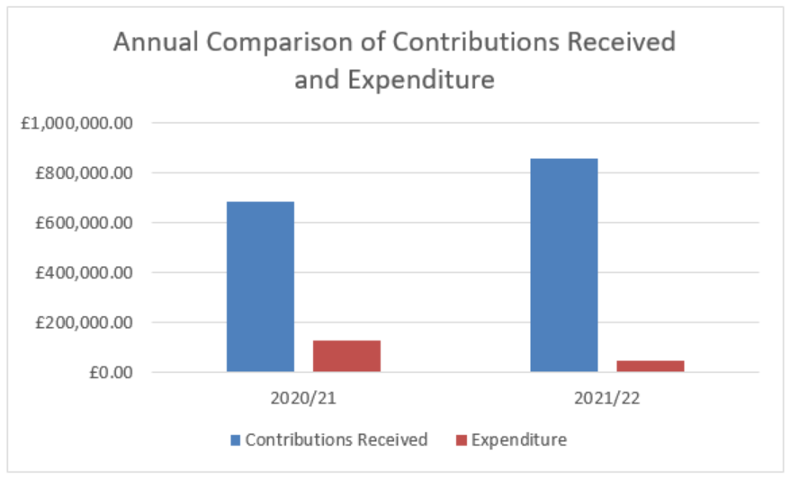
3.3 Capital Contributions retained at end of Financial Year 2021/22
Contributions collected through a Section 106 agreement usually have a clause stating the timeframe in which the contribution is to be expended. Currently there are no S106 contributions which have exceeded the timeframe and plans are in place to ensure that the contributions are expended prior to the repayment dates set.
In the majority of S106 agreements the payback period is usually 10 years however these clauses can range between 5 – 10 years.
Table 11 below details the Capital Contributions which have been retained at the end of the financial year 2021/22. These monies have yet to be allocated to a specific scheme or project.

Table 11. Capital Contributions held at 31st March 2022 (to the nearest £)
Site | Application Reference | S106 Received | Contributions Held | Provision | Deadline to for expenditure
Spring Lane | 2007/0748 | 2014 | £24,924 | Affordable Housing | 2024
 |  |  | £11,863 | Open Space
Land Between Main St and Hollinwood | 2012/0941 | 2019 | £99,536 | Open Space | 2029
Land at Wighay Road | 2014/0950 | 2016 | £94,822 | Open Space | 2026
 |  |  | £560,567 | Affordable Housing
 |  |  | £21,741 | Healthcare
Land at Stockings Farm | 2010/0437 | 2016 | £435,232 | Healthcare | 2026
Bradstone Drive, off Spring Lane | 2014/0740 | 2017 | £23,903 | Healthcare | 2027
Land North of Papplewick Lane, Linby | 2013/1406 | 2017 | £37,346 | Healthcare | 2027
 |  |  | £215,568 | Affordable Housing | 2028
 |  | 2020 | £454,104 | Affordable Housing | 2030
 |  |  | £81,739 | Healthcare | 2030
Land Off Cavendish Road | 2014/0559 | 2017 | £35,243 | Open Space | 2027
Land at Teal Close, Netherfield | 2013/0546 | 2019 | £111,237 | Healthcare | 2029
Land West of Westhouse Farm | 2014/0238 | 2019 | £27,818 | Healthcare | 2029
 |  | 2021 | £164,831 | Open Space | 2031
 |  | 2021 | £54,939 | Open Space | 2031
Land west of Beeston Close, Bestwood | 2017/0194 | 2020 | £36,826 | Open Space | 2030
Bradstone Drive, off Spring Lane | 2014/0740 | 2020 | £22,692 | Healthcare | 2030
Land to the West of Mapperley Plain | 2019/0213 | 2020 | £44,434 | Healthcare | 2030
Rolleston Drive | 2020/1054 | 2021 | £250,688 | Education | 2031
 |  |  | £25,000 | Bus Stop | 2031
 |  |  | £35,493 | Healthcare | 2031
96 Plans Road Mapperley | 2021/0737 | 2021 | £17,636 | Open Space | 2031
Park Road | 2018/0607 | 2021 | £17,500 | Open Space | 2031
 |  |  | £18,836 | Open Space | 2031
 |  |  | £98,372 | Healthcare | 2031
Mill Field Close, Burton Joyce | 2015/0424 | 2021 | £49,352 | Open Space | 2031
84-86 Chapel Lane, Ravenshead | 2019/0770 | 2021 | £30,359 | Open Space | 2031
Dark Lane | 2017/1263 | 2021 | £39,862 | Open Space | 2031
 |  |  | £18,713 | Healthcare | 2031
Glebe Farm | 2014/0475 | 2021 | £15,028 | Healthcare | 2031
Total |  |  | £3,176,204

Figure 4 below provides a breakdown of all the contributions currently held by Gedling Borough Council per service provision.
Figure 4. Pie Chart showing S106 Contributions held per type of provision
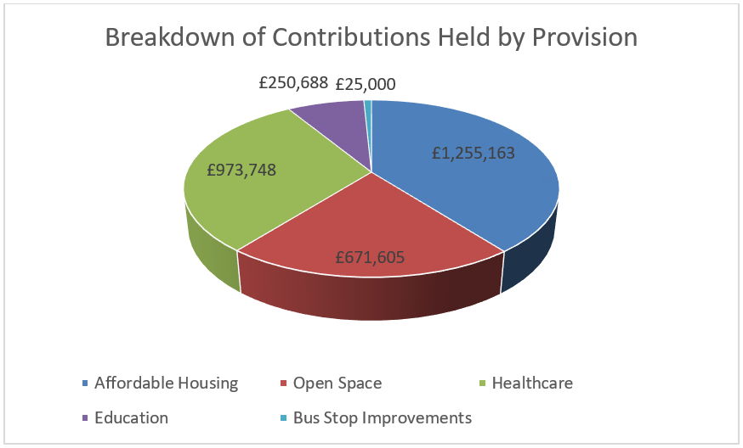
It should be noted that during the financial year 2021/22 Gedling Borough Council collected financial contributions, as part of Section 106 Agreements, towards the provision of both Education and Bus Stop Improvements. Whilst it is typically the responsibility of Nottinghamshire County Council to collect contributions regarding Education and Highways Improvements, in each of the relevant cases above, the County Council were the applicants for planning permission and as such were unable to collect the monies from themselves. Gedling Borough Council will release the monies in accordance with the terms and obligations of the relevant Section 106 Agreements.
3.4 Section 106 Capital and Revenue Expenditure
In 2021/22 Section 106 Contributions totalling £13,825 were spent on infrastructure projects across the borough. Table 12 indicates which developments the contributions were drawn down from and what projects they were allocated to.
Table 12. Capital Contributions expended during 2021/22 (to the nearest £)
Site | Application Reference | S106 Contribution Received | Amount Spent | Provision/Project Funded
Spring Lane, Mapperley | 2007/0748 | 2014 | £5,100 | Sand Martin Bank and Bird Hide, Gedling Country Park
Spring Lane, Mapperley | 2007/0748 | 2014 | £8,725 | Lambley Lane Changing Rooms & Pitch Renovation
Total |  |  | £13,825

As well as the collection and expenditure of capital contributions, it is not uncommon for Section 106 Agreements to require the payment of revenue contributions towards the ongoing maintenance of infrastructure which is provided. These payments are typically agreed for a period of 10 years. The majority of revenue contributions which are collected by Gedling Borough Council relate primarily to ongoing maintenance works on Open Spaces sites that the Council have adopted. Table 13 below sets out revenue contributions which have been collected by the Local Authority and the developments they have been spent on thus far.

Table 13. Revenue Contributions Received (to the nearest £)
Site | Date Received | Balance at 1st April 2021 | Annual Payment 2021/22 | Remaining Balance at 31st March 2022
Spring Lane | 2006 | £2,844 | £569 | £1,707
Park Road, Bestwood | 2006 | £17,880 | £0 | £17,880
Edison Way, Arnold | 2007 | £10,425 | £5,213 | £0
Downham Close, Arnold | 2008 | £4,126 | £825 | £2,476
Brooklands Drive | 2008 | £2,864 | £1,418 | £0
Arnold View Primary School | 2009 | £14,847 | £2,474 | £9,898
Burton Road, Gedling | 2009 | £3,819 | £763 | £2,292
188-194 Mapperley Plains | 2016 | £11,421 | £1,904 | £7,614
333-339 Mapperley Plains | 2016 | £14,453 | £2,409 | £9,635
Spring Lane | 2017 | £77,403 | £11,057 | £55,288
Land at Teal Close, Netherfield | 2018 | £2,550 | £0.00 | £2,550
Howbeck Road | 2020 | £30,956 | £3,096 | £24,764
Total |  | £193,588 | £29,729 | £134,104

3.5 Section 106 Monitoring Fees
The Community Infrastructure Levy (Amendment) (England) (No. 2) Regulations 2019 introduced a provision for Local Authorities to insert Monitoring Clauses into future Section 106 Agreements. These clauses allow fees to be levied to support the costs of monitoring and reporting on the delivery of Section 106 planning obligations.
Whilst the amendments to the Regulations allows for monitoring fees to be levied, any such fee must be both fair and reasonable based on the Local Authorities estimates of the actual costs of monitoring the agreement. The Borough Council has an adopted policy which can be viewed on the council’s website at the following link - https://democracy.gedling.gov.uk/documents/s16689/Appendix%201%20Monitoring%20Fee%20Ststement.pdf.
During the financial year 2021/22 Gedling Borough Council completed a total of 8 Section 106 Agreements which include the provision of a Monitoring Fees in accordance with the above policy. A list of these developments and the relevant monitoring fees, including monitoring fees which have been sought in relation to pre-existing agreements, are detailed below. Upon receipt of the monitoring fee the relevant records will be removed from the table.
Table 14. Section 106 Agreements with Monitoring Fees (to the nearest £)
Site | Date S106 Signed | Value of Monitoring Fee | Status
Land On Flatts Lane, Calverton, Nottinghamshire | 03.03.2020 | £2,835 | Payment Due
Land at Orchard Close, Burton Joyce, Nottinghamshire | 26.03.2020 | £2,520 | Not Commenced
Land at Brookfields Garden Centre, Mapperley Plains, Nottingham, NG3 5RW | 26.03.2020 | £2,205 | Not Commenced
Land at Chase Farm, Mapperley Plains, Mapperley, Nottingham | 09.07.2020 | £1,890 | Not Commenced
Land at the end of Linden Grove, Gedling, Nottingham | 28.01.2021 | £2,520 | Received
Land South Of Main Street, Calverton, Nottinghamshire | 07.04.2021 | £2,205 | Not Commenced
Land East of 16 Kighill Lane, Ravenshead, Nottinghamshire | 22.04.2021 | £315 | Payment Due
Car Park, North Green, Calverton, Nottinghamshire | 11.06.2021 | £630 | Not Commenced
The Phoenix, Shelford Road, Gedling, Nottinghamshire, NG4 4HU | 07.07.2021 | £630 | Received
Land At Rolleston Drive, Arnold, Nottinghamshire | 31.08.2021 | £1,260 | Received
Land North of Papplewick Lane, Linby, Nottinghamshire | 02.12.2021 | £945 | Received
96 Plains Road, Mapperley, Nottingham, NG3 5RH | 20.10.2021 | £315 | Received
Top Wighay Farm, Wighay Road, Linby, Nottinghamshire | 25.03.2022 | £5,040 | Not Commenced
Total |  | £23,310

3.6 Non-Monetary Contributions
In some instances, financial contributions may not be deemed necessary to mitigate against the impacts of a development. Instead it may be considered that the provision of on-site infrastructure such as Affordable Housing or, the agreement of future plans such as local employment schemes may be sufficient.
Table 15 details developments approved during the reporting year which include a provision to provide Affordable Housing on site.

Table 15. Provision of Affordable Housing 2021/22
Site Address | Application Reference | Date S106 Signed | Affordable Housing Obligation
Land South Of  Main Street  Calverton  Nottinghamshire | 2018/0360 | 07.04.2021 | 20% Affordable Housing (70% Affordable Rent and 30% Shared Ownership).
Car Park  North Green  Calverton  Nottinghamshire | 2018/0817 | 11.06.2021 | Affordable Housing provision of 4 dwellings or Off-Site Contribution of £10,617.00.
Land At Rolleston Drive  Arnold  Nottinghamshire | 2020/1054 | 31.08.2021 | 100% Affordable Housing provision – 85 Affordable Rent and 46 Shared Ownership.
Top Wighay Farm, Wighay Road, Linby, Nottinghamshire | 2020/0050 | 25.03.2022 | 17.64% Affordable Housing provision within each phase of the development – tenure split 70% Affordable Rent and 30% Shared Ownership.

Where appropriate, Section 106 Agreements also create opportunities to work with developers to ensure that, as well as providing a safe and attractive place to live for local residents to live, developments can provide a chance to support and improve the lives of our local residents by agreeing Employment and Skills Plans, also known as Local Labour Agreements. Through these Employment and Skills Plans it is possible to increase work place opportunities for local residents and involve our younger communities to increase skill sets and education.
Of the Section 106 Agreements completed in 2021/22, six included a requirement to submit an Employment and Skills Plan to the Local Planning Authority for signing off. Table 16 details the developments which require such obligations.
Table 16. Employment and Skills Plans Agreed 2021/22
Site | Date S106 Signed
Land South Of, Main Street, Calverton, Nottinghamshire | 07.04.2021
Car Park, North Green, Calverton, Nottinghamshire | 11.06.2021
The Phoenix, Shelford Road, Gedling, Nottinghamshire, NG4 4HU | 07/07/2021
Land at Ashdale, Nottingham Road, Burton Joyce, Nottinghamshire | 03/08/2021
Land At Rolleston Drive, Arnold, Nottinghamshire | 31/08/2021
Top Wighay Farm, Wighay Road, Linby, Nottinghamshire | 25/03/2022

3.7 Monies Borrowed
No Section 106 monies were spent repaying money borrowed during the financial year 2020/21.
4 GOING FORWARD – PLANNED EXPENDITURE
In accordance with the latest amendments to the CIL Regulations, the IFS outlines the future priorities in terms of expenditure over the next reporting period (2022/23).
The amount of CIL receipts generated in any given financial year is dependent upon the implementation of planning permissions and phasing of developments. Whilst it is possible to calculate the amount of CIL receipts expected through the totalling of Liability Notices generated, this will only ever be a theoretical figure as payment only becomes due upon the commencement of development.
Contributions generated through Section 106 Agreements must be spent in accordance with the terms set out within each Agreement (as negotiated during the planning application process). These terms will often have several trigger points, such as number of residential units occupied, which will cause the payment to become due. In this way, funding obtained through Section 106 agreements are heavily reliant upon the phasing and delivery of development and can vary greatly on a site by site basis, making it difficult to accurately forecast future income.
4.1 Strategic CIL
Since Gedling Borough Council first adopted the CIL in 2015 the Strategic portion of CIL Receipts have been ring-fenced for the provision of the Gedling Access Road (GAR). The GAR remains a vital piece of infrastructure to support growth in the area and provide greater connectivity between the central urbanised area of the Borough such as Mapperley and Arnold, and more rural settlements such as Burton Joyce and Stoke Bardolph. Until such a time as the funding gap for the GAR has been reached, CIL receipts for the Strategic element will continue to be ring-fenced for this piece of infrastructure.
Gedling Borough Council have committed to allocate a total of £4.48 million towards the Gedling Access Road. At the end of the financial year 2021/22 £4,097,740 has been collected through the Strategic portion of the CIL. It is expected that the remaining £382,260 will be collected during the next financial year 2022/23 and that the GAR payment can be made to the County Council, following the completion of a transfer agreement. .
Once the funding gap for the GAR has been reached the focus will shift towards secondary school contributions at Gedling Colliery / Chase Farm and Top Wighay Farm strategic sites. It is envisaged that the interim funding gap for Secondary School facilities required for these two developments can be reduced through education contributions delivered through Section 106 Agreements. Expenditure on a possible visitor centre at Gedling Country Park has also been approved. No decision have been taken with regards to the prioritisation of these projects.
4.2 Neighbourhood Portion CIL
The Neighbourhood CIL will continue to be spent on providing and improving existing infrastructure within the Borough. 15% of CIL receipts will continue to be allocated to the Neighbourhood portion of the CIL rising to 25% in places where a Neighbourhood Plan has been adopted.
The Neighbourhood portion of CIL receipts collected in local parishes will continue to be transferred directly to these governing bodies for allocation.
Throughout the year, local community groups and stakeholders will be able to nominate projects for the Neighbourhood portion of the CIL receipts which are collected within non-parish areas. Submissions can be made by completing the electronic form on the Gedling Borough Council website at the following link - https://apps.gedling.gov.uk/forms/default.aspx?formid=86.
In accordance with the CIL Regulations and Gedling Borough Councils CIL Guidance Note, an assessment of all the projects nominated throughout the year will commence in October. A Local Infrastructure Schedule (LIS) will be published along with a comprehensive project assessment for review prior to CIL Non-Parish Funding awards being granted. Following the publication of the LIS and project assessment a public consultation will be undertaken and a final report identifying which if any projects have been successful. If no projects are nominated or deemed appropriate the Neighbourhood CIL will be carried over to the next financial year.
Examples of types of Infrastructure which may be appropriate include:
- Improvements to local open spaces;
- Street improvements;
- Drainage improvements;
- Town centre regeneration and
- Recreational facilities.
It is important that any project which is nominated is able to demonstrate how it fulfils a need created by new development within the area and, should wherever possible, show availability to provide match funding through other revenue streams.
4.3 Section 106 Contributions
The Gedling 2022/23 capital programme sets out the future spending priorities of Gedling Borough Council. Currently three infrastructure projects totalling £71,800 have been identified in the next financial year. The projects which have been identified so far as suitable for Section 106 funding are detailed in table 17 below.
Table 17. Section 106 Contributions 2022/23 Allocations
Open Spaces
Sand Martin Bank & Bird Hide at Gedling Country Park £13,700 from Spring Lane 2007/0748 Contributions.
Lambley Lane Changing Rooms & Pitch Renovation £21,300 from Land Off Cavendish Road 2014/0559 Contributions.
Bestwood Country Park Car Park extension £36,800 from Land west of Beeston Close 2017/0194 Contributions.
Affordable Housing
No funding committed for 22/23 to date.
Healthcare
No funding committed for 22/23 to date.
Education
Education Contributions are requested and secured by Nottinghamshire County Council. The County Council are required to draft their own Infrastructure Funding Statement reporting on financial contributions received through S106 Agreements. A copy of this document will be available for viewing on Nottinghamshire County Councils website.

Careful consideration will be given to remaining Section 106 Contributions which are being held by Gedling Borough Council. These remaining sums will be monitored and projects identified in accordance with the relevant legal S106 Agreements.
5 Infrastructure List
Table 18. The Infrastructure List
Community Infrastructure Levy
Construction of Gedling Access Road to facilitate Gedling Colliery / Chase Farm development. | To be funded through Strategic portion of CIL Receipts collected.
Secondary School Contributions at Gedling Colliery / Chase Farm and Top Wighay Farm developments. | To be funded through Strategic portion of CIL Receipts collected.
Gedling Colliery Country Park Visitors Centre | To be funded through Strategic portion of CIL Receipts collected.
Annual assessment of suitable Infrastructure projects identified in accordance with Regulation 59F of the Community Infrastructure Levy (Amendment) (England) (No. 2) Regulations 2019. | To be funded through the Neighbourhood portion of CIL Receipts collected.
Section 106 Contributions
Provision of Affordable Housing Units either on-site of through capital contributions. | To be secured through Section 106 Obligations.
Provision of Open Spaces including new infrastructure and improvements to existing sites. | To be secured through Section 106 Obligations.
Provision for Primary Healthcare including new infrastructure and improvements of existing surgeries. | To be secured through Section 106 Obligations.
Any other future infrastructure which is deemed necessary, in accordance with the Community Infrastructure Levy (Amendment) (England) (No. 2) Regulations 2019 | To be secured through Section 106 Obligations.

The above is not a final account of all infrastructure that may be funded through Planning Obligations. The Infrastructure List will be monitored and may be updated accordingly to represent new projects that are identified in the future.
If you have any further queries or comments about this statement, please do not hesitate to contact us via email at CIL@gedling.gov.uk or phone on 0115 901 3731.

